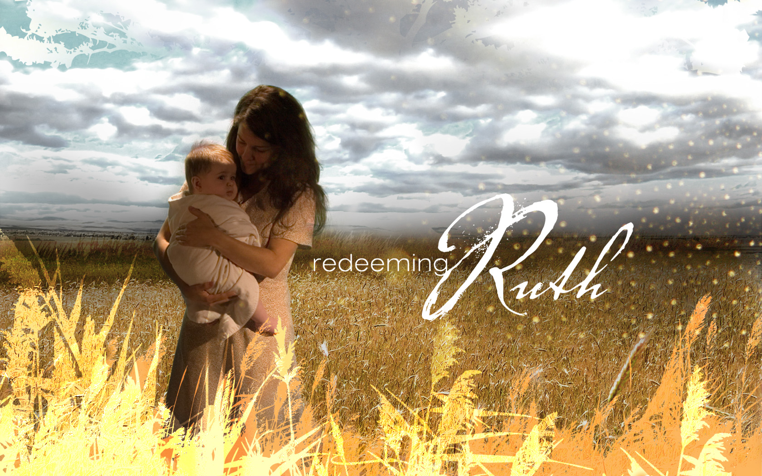
Redeeming Ruth

Embracing the Romance of Redemption

Part 1

“What do you want on your tombstone?”

Ruth 1:1-6

Your tombstone will speak of:

- How you live amidst dreadful circumstances.

Ruth begins in a time of a

- Moral famine
- Material famine

These famines come as a result of:

- Apathy
- Apostasy
- Anarchy
- The decisions you make at the crossroads of life.

Elimelech:

  - Left a promised land
  - Lived and lingered in a polluted land

- Your response to devastating calamities.

What is your response to:

- Disease
- Death
- Defeat

- The results of your difficult choices.

Our choices should involve:

- Drawing near to God
- Understanding what God is doing
- Taking inventory of past decisions


May 6, 2007 Redeeming Ruth
Tim Badal copyrighted © 2007 Part 1
Redeeming Ruth

Embracing the Romance of Redemption

Part 1

“What do you want on your tombstone?”

Ruth 1:1-6

Your tombstone will speak of:

- How you live amidst dreadful circumstances.

Ruth begins in a time of a

- Moral famine
- Material famine

These famines come as a result of:

- Apathy
- Apostasy
- Anarchy
- The decisions you make at the crossroads of life.

Elimelech:

  - Left a promised land
  - Lived and lingered in a polluted land

- Your response to devastating calamities.

What is your response to:

- Disease
- Death
- Defeat

- The results of your difficult choices.

Our choices should involve:

- Drawing near to God
- Understanding what God is doing
- Taking inventory of past decisions

April 8, 2007 Redeeming Ruth
Tim Badal copyrighted © 2007 Part 1

