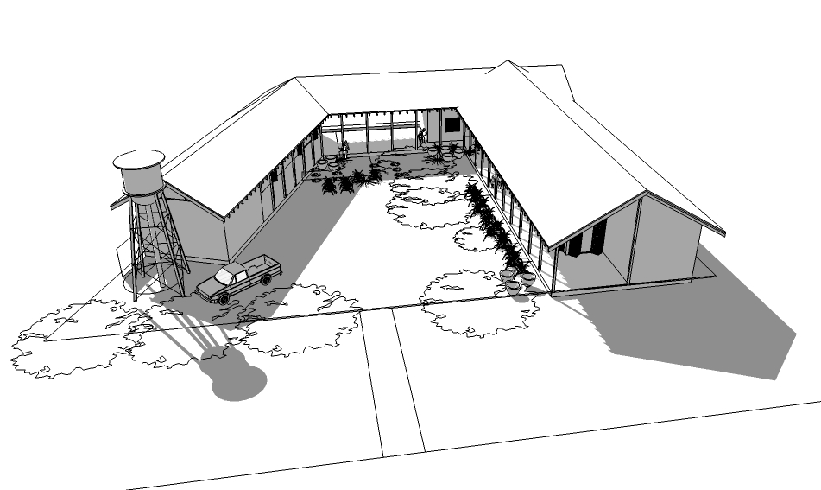

Breakthrough Teen Complex

In partnership with Servantworks and The Well Bangkok, the Breakthrough Thailand team is looking to raise $70,000 to fund construction of a teen living and learning complex in Thailand's rural, Northeast region.

The complex will facilitate additional programming in prevention of sexual exploitation in one of Thailand's most vulnerable regions, including residential teen discipleship, alternative education and skills training.

Breakthrough Thailand: Vision and Mission

Through community-driven efforts, Breakthrough Thailand seeks to strike at the roots of trafficking and exploitation by restoring and transforming families, education systems and economic paradigms in Thailand’s rural Isaan communities.
The Breakthrough community does this through:
- Investment in continued education and leadership training for at-risk teens and young adults
- Modeling and teaching healthy relationships, parenting methods and family dynamics
- Exploration of an “alternative economics” for Isaan youth and families including sufficiency living, creative discovery, and innovative income generation

Background
In May 2012, a team of three young professional women and five Thai teenagers moved from bustling Bangkok to a small, rural village in Northeast Thailand to begin an experiment in rural teen discipleship and leadership development. In the short 18 months that followed, the “experiment” showed surprising results in lives changed and communities reached.
As of November 2013, twelve at-risk teenagers have been enrolled in a local public school and voluntarily participating a strict discipleship and leadership development program. Prior to entering the Breakthrough program, many of these young women were on the verge of dropping out of school or otherwise exhibiting high risk of unhealthy behaviors. The teen girls are now being discipled and tutored in a home environment, and are showing signs of leadership in their school and home communities.
As a part of their education and discipleship, the teens and staff/mentors facilitate a number of community outreach activities, including tutoring village youth; reading programs; offering skills training opportunities; partnering with the local church, schools and police units; and facilitating sports, games and other positive youth activities.

Looking Forward: A Focus on Education
Teens entering the residential program, and many village teens, have little or no educational foundation on which to build and compete effectively in a traditional school context. Many struggle with basic language and literacy, let alone more complex areas of critical thinking and problem solving.
Breakthrough is seeking to increase the quality of educational services provided in the community through two stages. First, through increased investment in after-school tutoring services as a bridge toward providing more formal alternative/supplemental education for teens interested in completing a high school equivalency.
The first stage of activities is in progress as current staff and mentors are providing tutoring services to residential and local youth and recruiting local volunteers to supplement teaching. However, an increase in quality of the educational services provided – particularly if moving toward a more formal “alternative education” program – is largely dependent on the recruitment of qualified educators (both local and foreign) that hold the same values and are willing to live and work in an isolated, rural context.
The Complex
The Breakthrough family has quickly outgrown its makeshift quarters living out of the single-bedroom home of one of the founding staff. Recognizing opportunities to increase the quality of education and programming offered both to the residential teens as well as other at-risk teens in the village and surrounding areas, the Breakthrough team is seeking to expand facilities in the local village through the construction of a Breakthrough Teen Complex.
The Teen Complex would facilitate the following forward-looking goals:
- Provide a safe, healthy and modest “living and learning” environment for residential teens
Living quarters – including sleeping, cooking, eating, washing and studying – for up to 15 residential teens, house parents and staff/volunteers
- Provide a positive alternative hangout for residential and village youth
Community center including library, computer/study room, music room, game area, coffee shop/marketplace, sport court and gardens
- Increase quantity and quality of educational services and skills training provided
Convertible classroom and work space, library and hands-on skills training through agriculture, gardening, metal-working or other enterprises

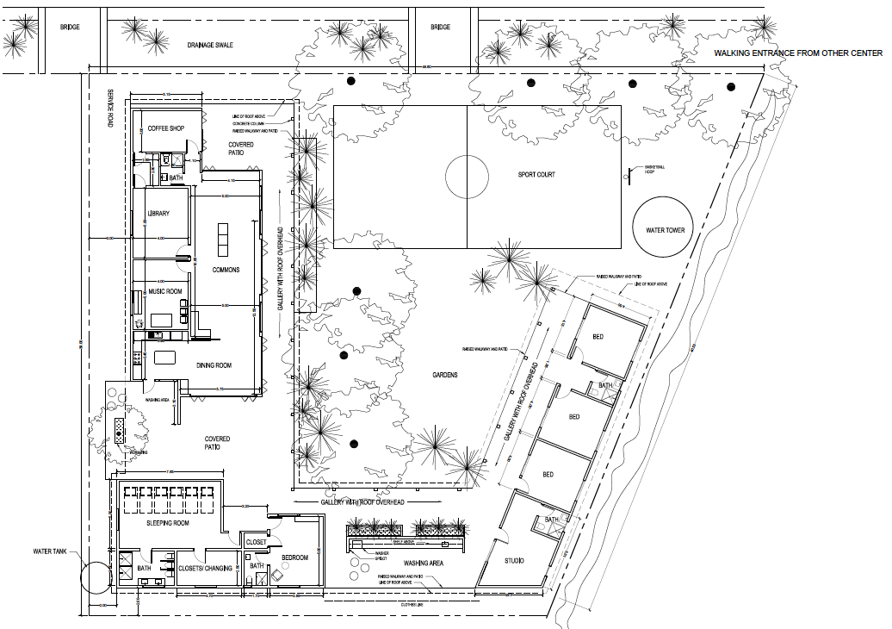

Program Budget Outline
- Residential Teen Scholarships
2,000 baht (US$70) per month per student
Average 12 teens = 24,000 baht (US$840/mo)
- Staff Support
Two full-time residential staff; two full-time “mentors in training”
50,000 baht ($1650/mo)
- Special Project: Breakthrough Teen Complex
Rough budget estimate: US$70,000

